AI-Powered Code Review Assistant
1. PROBLEM DEFINITION
Modern software teams and individual developers often face slow, inconsistent, and time-intensive code reviews. Reviewing code manually requires expertise, attention to detail, and coordination between developers — which leads to delays, human oversight, and missed security or performance issues.
Small development teams and independent developers especially struggle because:
- They may not have dedicated reviewers,
- Reviewing every pull request is time-consuming,
- Ensuring code quality across contributors is difficult,
- Security, style, and performance checks are not consistently enforced.
This results in:
- Slower development cycles,
- Undetected bugs and vulnerabilities,
- Code quality variations,
- Increased technical debt.
There is a need for an AI-assisted, automated, and developer-friendly code review platform that:
- Analyzes code instantly,
- Detects bugs, security flaws, and style violations,
- Suggests fixes with explanations,
- Reduces dependency on manual review efforts.

2. PROJECT OBJECTIVES
Primary Objectives
- Develop an AI-powered code review system that analyzes submitted code automatically.
- Detect security risks, bugs, style issues, and best-practice violations using static analysis tools.
- Use AI/LLMs to generate human-like explanations and patch suggestions for detected issues.
- Provide an intuitive web interface for uploading/viewing code and reviewing suggestions.
- Reduce the time and effort spent on manual code reviews for individuals and teams.
Secondary Objectives
- Support multiple programming languages (starting with Python).
- Allow inline comments, discussions, and prioritized issue views.
- Offer downloadable fixes or patch previews.
- Enable GitHub integration (optional, for advanced phase).
- Store analysis results and history efficiently using PostgreSQL.
Long-Term Scope (Future Enhancements)
- Real-time review on PRs via GitHub/GitLab.
- AI-based ranking of high-risk issues.
- Multi-language support (Java, JS/TS, etc.).
- Autofix-on-commit workflows.
- Team collaboration & reporting dashboard.

SRS Document
Project Title: AI-Powered Code Review Assistant
Version: 1.0
Date: October 2025
Author: Eshal Shanoj
Table of Contents
- Introduction
1.1 Purpose
1.2 Scope
1.3 Stakeholders
1.4 Definitions, Acronyms
- Overall Description
2.1 Product Perspective
2.2 Product Functions
2.3 User Characteristics
2.4 Constraints & Assumptions
- Functional Requirements
- Non-Functional Requirements
- System Architecture & Data Flow
- Database Design
- External Interfaces
- Tools & Technologies
- Risks & Mitigations
- Future Enhancements
- Timeline & Milestones
- Glossary
1. Introduction
1.1 Purpose
Manual code reviews are time-consuming, inconsistent, and prone to human oversight. Small teams and individual developers often lack dedicated reviewers, resulting in slower development cycles, undetected bugs, and varying code quality.
This project develops an AI-Powered Code Review Assistant that combines static analysis tools with AI/ML models to detect issues, generate explanations, and provide suggested fixes.
1.2 Scope
The system enables:
- Secure login (GitHub OAuth).
- Code upload or repo integration.
- Automated static analysis and AI-powered suggestions.
- Review dashboard with explanations, severity, and fix previews.
- Persistent storage of reports.
Future scope includes multi-language support, GitHub/GitLab PR integration, collaboration dashboards, and custom model training.
1.3 Stakeholders
- Primary Users: Developers, freelancers, and small teams.
- Secondary Users: Open-source maintainers, students.
- Admin: Manage system configurations, thresholds, logs.
1.4 Definitions, Acronyms
- LLM: Large Language Model
- FR: Functional Requirement
- NFR: Non-Functional Requirement
- JSONB: PostgreSQL JSON Binary type
- PR: Pull Request
2. Overall Description
2.1 Product Perspective
A cloud-ready, microservice-based web system: Angular frontend, Spring Boot backend, PostgreSQL (with pgvector), AI microservice with FastAPI + Ollama (local LLM), and static analysis workers (Pylint/ESLint/PMD).
2.2 Product Functions
- Authenticate via GitHub OAuth.
- Upload/scan code, store snapshots.
- Perform static analysis.
- Generate AI-based explanations and patch suggestions.
- Display results in interactive UI (Monaco Editor).
- Allow inline comments & patch downloads.
- Store history of reviews for users/projects.
2.3 User Characteristics
- Developers with basic GitHub familiarity.
- Small teams without dedicated reviewers.
- Admin users monitoring logs and usage.
2.4 Constraints & Assumptions
- Internet connectivity required for AI API.
- Only text-based source code allowed.
- Free tiers used where possible (Docker, PostgreSQL, MinIO, Redis).
- Code is not executed, only analyzed.
3. Functional Requirements
Authentication
FR-01.1: System shall authenticate users via GitHub OAuth.
FR-01.2: System shall issue JWT for session handling.
Project & Review Management
FR-02.1: Users can create projects and reviews.
FR-02.2: Reviews can be created via file upload or repo link.
FR-02.3: System shall store past reviews.
Static Analysis
FR-03.1: Run Pylint, Flake8, Bandit (Python) in MVP.
FR-03.2: Store raw tool outputs in DB.
AI Analysis
FR-04.1: Generate natural language explanations per finding.
FR-04.2: Suggest patch (validated via git apply).
FR-04.3: Store AI output in JSONB.
Dashboard & Collaboration
FR-05.1: Display issues by severity/type.
FR-05.2: Allow inline comments.
FR-05.3: Export report (PDF/HTML).
Admin & Monitoring
FR-06.1: Admin can view logs, metrics.
FR-06.2: Provide audit logging.
4. Non-Functional Requirements
- Performance: Reviews for small repos under 3 minutes.
- Scalability: Microservice + queue architecture for parallel jobs.
- Security: OAuth 2.0, input sanitization, secret detection.
- Usability: Responsive UI, real-time progress indicators.
- Reliability: Job retries, status durability.
- Maintainability: Modular, containerized services.
5. System Architecture & Data Flow
High-Level Architecture:
- Frontend: Angular + Monaco → interacts with Spring Boot REST API.
- Backend: Spring Boot orchestrates → PostgreSQL & MinIO for persistence → Redis queue → Python workers.
- AI Service: FastAPI + Ollama (local LLM) → processes code input → generates feedback, summaries, and patch suggestions.
Data Flow (Level-1):
- User login via GitHub OAuth.
- User uploads repo snapshot.
- Backend enqueues analysis job.
- Static worker runs linters → stores findings.
- AI worker enriches findings → explanations + patch.
- Backend aggregates report.
- User views interactive dashboard.
6. Database Design
Tables (initial):
- users: user_id, github_id, email, role, created_at
- projects: project_id, owner_id, name, repo_url
- reviews: review_id, project_id, status, language, created_at
- files: file_id, review_id, path, sha256, size
- findings: finding_id, review_id, file_id, rule_id, severity, snippet, static_detail (JSONB), ai_detail (JSONB), embedding (pgvector optional)
- comments: comment_id, review_id, file_id, user_id, line, text
- jobs: job_id, type, payload JSONB, status
- logs: log_id, event, timestamp
7. External Interfaces
- User Interface: Angular SPA + Monaco Editor.
- API: REST (Spring Boot) + SSE for updates.
- AI Service: FastAPI microservice (Ollama local LLM).
- Static Tools: Pylint, Bandit, ESLint, PMD.
- Auth: GitHub OAuth.
8. Tools & Technologies
Layer | Tools / Tech
Frontend | Angular, TypeScript, Monaco Editor
Backend | Java Spring Boot
AI Service | Python, FastAPI, Ollama (Llama 3/Code Llama model)
Database | PostgreSQL + pgvector (optional)
Static Analysis | Pylint, Flake8, Bandit, ESLint, PMD
Storage | MinIO (local), AWS S3 (cloud)
Queue | Redis
Auth | GitHub OAuth
Deployment | Docker, AWS/GCP/Render
CI/CD | GitHub Actions

9. Risks & Mitigations
- LLM cost overruns → use local models (Llama2) for dev.
- AI hallucinations → validate patches, mark low-confidence issues.
- Code privacy → encrypted storage, user deletion option.
- Scaling → containerized workers, queue system.
10. Future Enhancements
- Multi-language support (Java, JS/TS, etc.).
- Real-time GitHub/GitLab PR review.
- Autofix PR bot.
- Team dashboards and analytics.
- Fine-tuned AI models for enterprise domains.
11. Timeline & Milestones
Week | Milestone
1–2 | Finalize SRS, repo setup, architecture
3–5 | Static analysis module + DB integration
6–8 | AI service integration (FastAPI + Ollama)
9–10 | Angular UI + Monaco Editor integration
11–12 | Testing + refinements
13–14 | Deployment (Docker + cloud), docs
12. Glossary
- Code Review: Process of checking source code for issues.
- Static Analysis: Automated code scanning without executing code.
- Patch/Diff: Suggested code changes in unified format.
- OAuth 2.0: Authentication protocol used with GitHub.
- pgvector: PostgreSQL extension for vector embeddings.

System Architecture Diagram
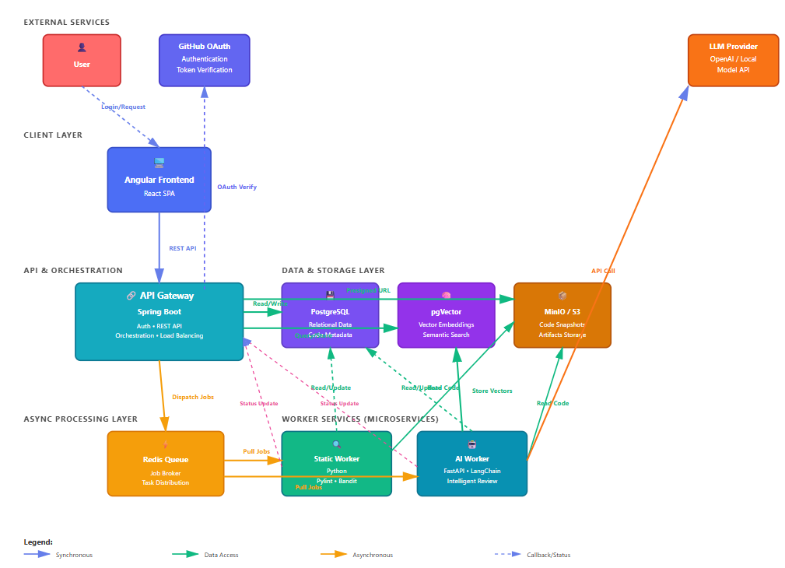
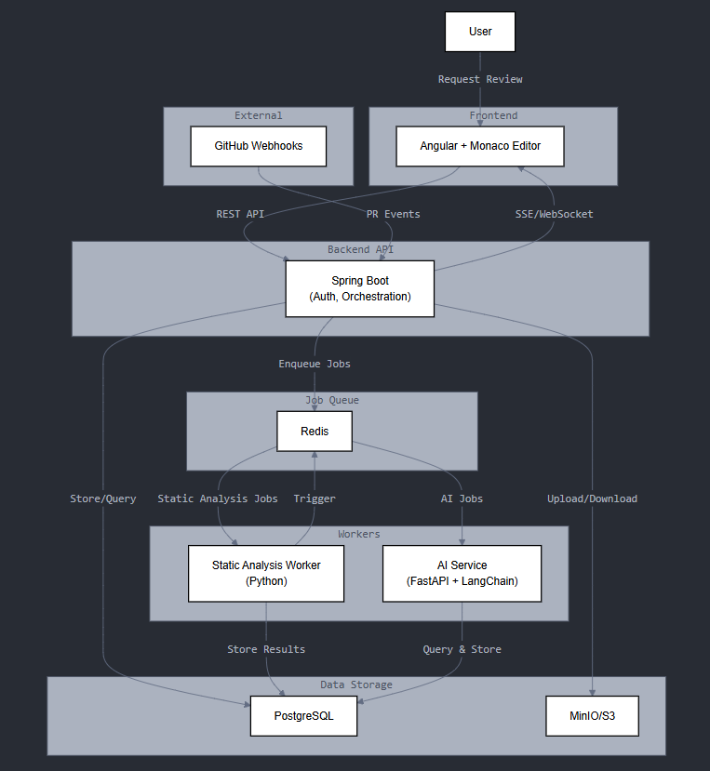
Level-1 Data Flow Diagram (DFD) 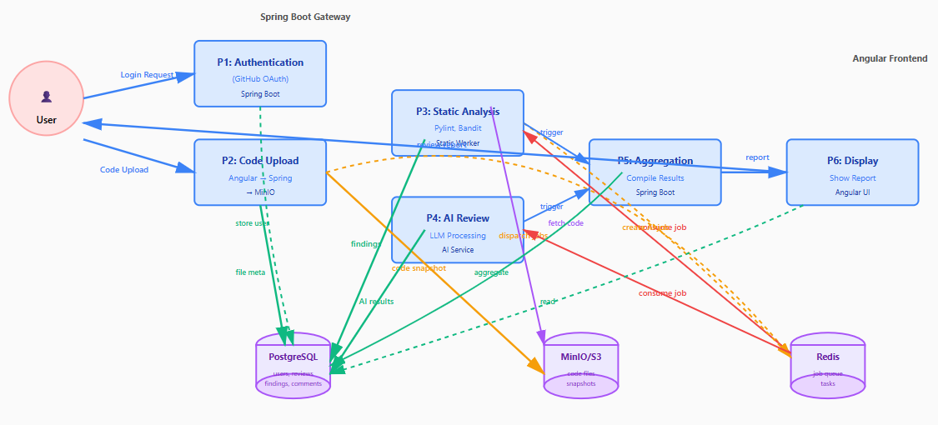 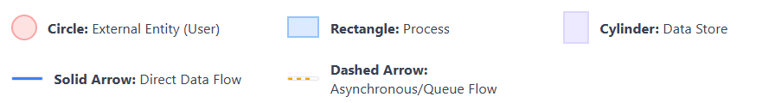
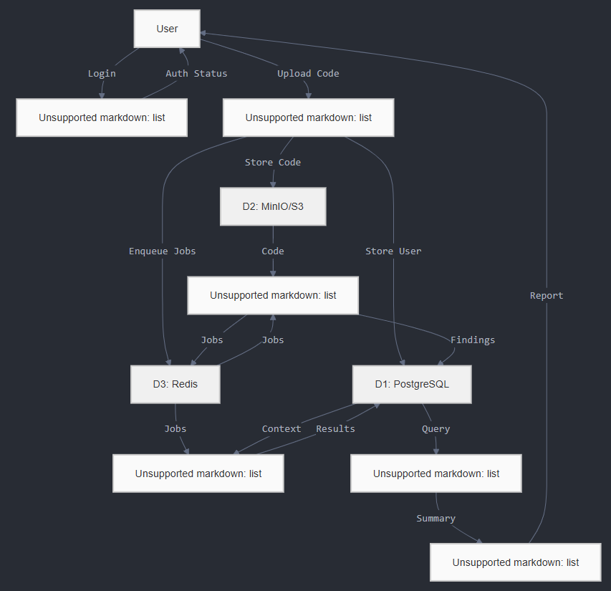
Deployment Diagram
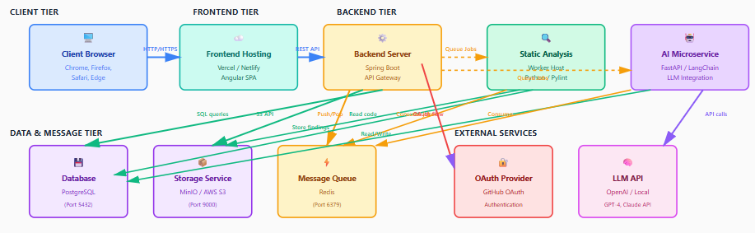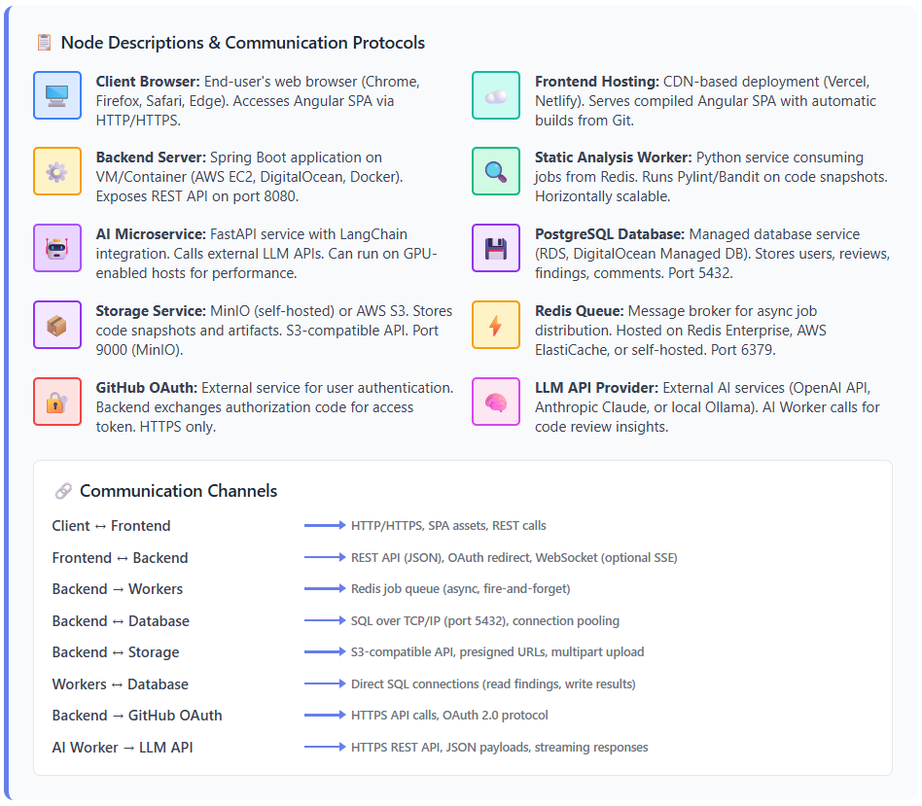

DATABASE SCHEMA (PostgreSQL + JSONB + pgvector)
-- ✅ Enable required extensions
CREATE EXTENSION IF NOT EXISTS "uuid-ossp";
CREATE EXTENSION IF NOT EXISTS "pgvector";

-- ================================================
-- 1) USERS TABLE
-- ================================================
CREATE TABLE users (
user_id UUID PRIMARY KEY DEFAULT uuid_generate_v4(),
name TEXT,
email TEXT UNIQUE NOT NULL,
github_id TEXT UNIQUE,
avatar_url TEXT,
role TEXT DEFAULT 'user', -- 'user', 'admin'
created_at TIMESTAMP DEFAULT NOW()
);

-- ================================================
-- 2) PROJECTS TABLE
-- ================================================
CREATE TABLE projects (
project_id UUID PRIMARY KEY DEFAULT uuid_generate_v4(),
owner_id UUID NOT NULL REFERENCES users(user_id) ON DELETE CASCADE,
name TEXT NOT NULL,
repo_url TEXT,
visibility TEXT DEFAULT 'private', -- 'private', 'team', 'public'
created_at TIMESTAMP DEFAULT NOW()
);

-- ================================================
-- 3) REVIEWS TABLE
-- ================================================
CREATE TABLE reviews (
review_id UUID PRIMARY KEY DEFAULT uuid_generate_v4(),
project_id UUID NOT NULL REFERENCES projects(project_id) ON DELETE CASCADE,
status TEXT NOT NULL, -- e.g., 'queued', 'analyzing', 'complete', 'failed'
language TEXT NOT NULL, -- e.g., 'python', 'javascript', 'java'
upload_key TEXT, -- Reference to S3/MinIO object
summary JSONB, -- Aggregated results or metadata
created_at TIMESTAMP DEFAULT NOW(),
completed_at TIMESTAMP
);

-- ================================================
-- 4) FILES TABLE
-- ================================================
CREATE TABLE files (
file_id UUID PRIMARY KEY DEFAULT uuid_generate_v4(),
review_id UUID NOT NULL REFERENCES reviews(review_id) ON DELETE CASCADE,
path TEXT NOT NULL,
sha256 TEXT,
size_bytes INT,
language TEXT, -- useful if multi-language mix
created_at TIMESTAMP DEFAULT NOW()
);

-- ================================================
-- 5) FINDINGS TABLE
-- ================================================
CREATE TABLE findings (
finding_id UUID PRIMARY KEY DEFAULT uuid_generate_v4(),
review_id UUID NOT NULL REFERENCES reviews(review_id) ON DELETE CASCADE,
file_id UUID REFERENCES files(file_id) ON DELETE CASCADE,
language TEXT NOT NULL, -- matches or derived from file
tool_name TEXT NOT NULL, -- 'pylint', 'eslint', 'pmd', etc.
rule_id TEXT,
type TEXT, -- 'bug', 'security', 'style', 'performance'
severity TEXT, -- 'low', 'medium', 'high', 'critical'
line_start INT,
line_end INT,
snippet TEXT,
static_detail JSONB, -- raw tool output
ai_detail JSONB, -- { explanation, patch, confidence, ... }
created_at TIMESTAMP DEFAULT NOW()
);

-- ================================================
-- 6) COMMENTS TABLE
-- ================================================
CREATE TABLE comments (
comment_id UUID PRIMARY KEY DEFAULT uuid_generate_v4(),
review_id UUID NOT NULL REFERENCES reviews(review_id) ON DELETE CASCADE,
file_id UUID REFERENCES files(file_id) ON DELETE CASCADE,
user_id UUID NOT NULL REFERENCES users(user_id) ON DELETE CASCADE,
line INT,
body TEXT NOT NULL,
created_at TIMESTAMP DEFAULT NOW()
);

-- ================================================
-- 7) JOBS TABLE (QUEUE TRACKING)
-- ================================================
CREATE TABLE jobs (
job_id UUID PRIMARY KEY DEFAULT uuid_generate_v4(),
type TEXT NOT NULL, -- 'static' | 'ai' | etc
payload JSONB NOT NULL,
status TEXT NOT NULL, -- 'queued', 'running', 'done', 'error'
error TEXT,
created_at TIMESTAMP DEFAULT NOW(),
updated_at TIMESTAMP DEFAULT NOW()
);

-- ================================================
-- 8) LOGS TABLE
-- ================================================
CREATE TABLE logs (
log_id UUID PRIMARY KEY DEFAULT uuid_generate_v4(),
event TEXT NOT NULL,
meta JSONB,
created_at TIMESTAMP DEFAULT NOW()
);

-- ================================================
-- OPTIONAL: INDEXES FOR PERFORMANCE
-- ================================================
CREATE INDEX idx_reviews_project_id ON reviews(project_id);
CREATE INDEX idx_files_review_id ON files(review_id);
CREATE INDEX idx_findings_review_id ON findings(review_id);
CREATE INDEX idx_findings_file_id ON findings(file_id);
CREATE INDEX idx_findings_language ON findings(language);
CREATE INDEX idx_findings_tool_name ON findings(tool_name);
CREATE INDEX idx_jobs_status ON jobs(status);
CREATE INDEX idx_comments_review_id ON comments(review_id);
CREATE INDEX idx_comments_file_id ON comments(file_id);

-- ================================================
-- OPTIONAL: If using pgvector for embeddings later
-- ================================================
-- ALTER TABLE findings
-- ADD COLUMN embedding VECTOR(768); -- or chosen dimension

Monorepo Folder Structure
ai-code-review-assistant/
│
├── frontend/ # Angular + Monaco
│ ├── src/
│ ├── angular.json
│ ├── package.json
│ └── README.md
│
├── backend/ # Spring Boot (API + DB + Auth)
│ ├── src/
│ ├── pom.xml
│ ├── application.yml
│ └── README.md
│
├── ai-service/ # FastAPI + Ollama worker
│ ├── app/
│ ├── requirements.txt
│ └── README.md
│
├── static-analysis-worker/ # Python worker for pylint/bandit/etc.
│ ├── src/
│ ├── requirements.txt
│ └── README.md
│
├── database/
│ ├── schema.sql # ✅ Your final DB file
│ ├── migrations/ # (if using Liquibase/Flyway later)
│ └── seed.sql # optional
│
├── infra/ # Docker, CI/CD, deployment
│ ├── docker-compose.yml
│ ├── Dockerfile.backend
│ ├── Dockerfile.frontend
│ ├── Dockerfile.ai
│ ├── Dockerfile.worker
│ ├── nginx.conf (optional)
│ └── README.md
│
├── docs/ # All documentation (SRS, diagrams, etc.)
│ ├── SRS-Final.docx
│ ├── architecture-diagram.png
│ ├── dfd.png
│ └── README.md
│
├── .gitignore
├── README.md # Project overview + setup steps
└── LICENSE (optional)

